the potential economic impacts of the
red imported fire ant in New Zealand

MAF Policy
September 2001

Abstract

This paper outlines the estimation of the potential economic impacts of the red imported fire ant in the North Island and upper South Island of New Zealand under minimal government intervention. Evaluation of selected impacts on households, infrastructure and agriculture suggests that, following range expansion and consolidation, the full annual costs of living with the red imported fire ant would be at least $318 million. The present value of the total impacts over a 23-year period of range expansion and consolidation from initial establishment is indicated to be at least $665 million.

Introduction

Native to Southern Brazil, the red imported fire ant, Solenopsis invicta, (the fire ant) has established in many of the southern states of the USA. In February 2001 it was detected for the first time in Brisbane, Australia. A fire ant nest was found subsequently at Auckland international airport. This nest was destroyed and the ants killed and, to date, there have been no further signs of the fire ant in New Zealand.

Omnivorous, opportunistic and aggressive, the fire ant has become a significant environmental, economic and human health pest outside of its native range and has the potential to establish across much of New Zealand.

The purpose of this economic impact assessment is to estimate the potential costs to New Zealand of the fire ant, were it to become established. The benefit of successfully preventing the fire ant from establishing in New Zealand is the avoidance of these costs.

Methodology

The impacts of the fire ant in New Zealand, were it to establish here, are estimated on the basis of the impacts experienced currently in Texas and other southern states of the USA, where the fire ant is well established and its impacts documented, with adjustment for New Zealand conditions.

The economic impact assessment models the impacts of the fire ant under not quite no government intervention but minimal government involvement in the form of a small amount of government expenditure on facilitating the effective management of the fire ant by individuals and groups undertaking their own treatment activities. This provides a baseline with which to compare control options available to government to avert, reduce or postpone the impacts of the fire ant in New Zealand.

The impacts modelled comprise a combination of damage and treatment costs, given current technology. Individuals and groups who may be affected by the fire ant may treat their properties to reduce the level of damage of which they are at risk. Fire ant treatment may, however, be technically and/or economically feasible only up to a point.

The fire ant, as a pest in both urban and rural areas, can have a very wide range of impacts. The economic impact assessment models selected impacts on:
- households;
- infrastructure; and
- agriculture.

All unit costs are expressed in 2001 New Zealand dollars, using, where necessary, consumer price indices (Bureau of Labour Statistics, US Department of Labour; Statistics New Zealand) and a five year average exchange rate (Reserve Bank of New Zealand). In expressing future impacts in present value terms, the discount rate is set at ten per cent.

Household impacts

The cost components of the household impacts modelled are:
- fire ant treatment costs;
- repair and replacement costs;
- medical costs;
- pet treatment costs; and
- the value of forgone outdoor household activities.

Fire ant treatment costs
The average annual cost per household of fire ant treatment is set at $133.31 (Lard et al., 2001a). This comprises expenditure on materials, equipment and professional pest control services, for treatment of, predominantly, gardens, landscapes and children’s play areas, but also outside electrical and other equipment and, to a limited extent, inside houses. This does not include the value of time spent by householders on treatment activities.

Repair and replacement costs
The average annual cost per household of repairs to property and equipment and replacement of equipment, including electrical equipment, damaged by the fire ant is set at $150.65 (Lard et al., 2001a). Again, the value of time spent by householders on these activities is not included. No adjustment is made for differences in the average size and other characteristics of residential properties in Texas and New Zealand.

There is a wide range in the average annual household treatment, repair and replacement costs reported in the USA (Loope, 2000; Miller et al., 2000; University of Arkansas, 2001), in which the costs reported by Lard et al. (2001a) are around mid-range.

Medical costs
In modelling medical expenses associated with fire ant stings, it is assumed that each year 32 per cent of the population of infested areas are stung by the fire ant (Lofgren and Adams, 1982). Of these, it is assumed that three per cent seek medical attention and 0.5 per cent have serious or life-threatening reactions requiring hospitalisation (Texas A&M University, 2001) of, on average, one day in length (Adams and Lofgren, 1982). It is assumed that each person seeking medical attention consults a GP at least once, with an average of two GP consultations per person assumed for the seven per cent receiving medical attention for secondary infections (Adams and Lofgren, 1982). The costs of this medical attention are set at $38.36 per GP consultation (Statistics New Zealand) and $654.97 per hospital bed per day (Scott et al., 2000), with the addition of transportation costs of $3.19 per GP consultation and $6.38 per hospitalisation (Scott et al., 2000). The average cost of medication, either first aid, such as antiseptics and insect bite or sting treatments, or prescription, such as antibiotics and asthma treatment medications, is assumed to be $1.50 per person stung. Additional to these costs are labour productivity losses due to absence from work and the value of any lives lost. Further medical costs, as well as fatalities, may arise from accidents resulting from fire ant damage to equipment, including electrical equipment (e.g. security lighting, traffic lights).

The medical costs modelled are low compared with average household medical expenses due to fire ant stings reported in the USA (Diffie and Sheppard, 1991; Lard et al., 2001a; Miller et al., 2000). The proportion of the population stung by the fire ant can range from 30 to 60 per cent (VanGelder, 2001), exceeding 50 per cent in heavily infested areas (Loope, 2000), of whom between 0.5 per cent (University of Queensland, 2001) and 5 per cent (Loope, 2000) seek medical attention, with a little under one per cent of the population hypersensitive to the fire ant stings (Lennon, 1998; Merchant, 1998; VanGelder, 2001; Vinson, 1997).

Pet treatment costs
The average annual cost of treating pets for fire ant stings is set at $2.23 per household across all households (based on the city findings reported in Lard et al., 2001a). This comprises expenditure on injections and medicated shampoos. Miller et al. (2000) reports a slightly lower average veterinary expense per household, whilst a considerably higher average expenditure per pet owner on veterinary costs related to fire ant stings is reported in Texas A&M University (2001). As in humans, some individuals may have severe allergic reactions to fire ant stings. Veterinary expenses in such cases can be considerable. Fire ant stings can cause death in small or weakened animals, representing an additional cost in terms of the loss of the value of these pets to their owners.

Forgone outdoor household activities
It is assumed that 27 per cent of households reduce their use of, or stop using, their gardens or yards due to the presence of the fire ant (Lard et al., 2001a). The outdoor household activities reported to be curtailed include gardening, landscaping, picnicking, sunbathing, swimming and children’s play. The average value of forgone activities is set at $281.87 per year for each household curtailing its outdoor activities (Lard et al., 2001a).

The above unit costs are applied to New Zealand population and household data (Census 2001 - provisional, Statistics New Zealand). A potential household impact not modelled is reduced residential property values for infested sites relative to non-infested sites.

Infrastructure impacts

Also modelled are wider infrastructure impacts on:
- highways;
- electricity, telephone and cable services;
- public access urban areas;
- school grounds; and
- golf courses.

Highways
The annual cost of repairing highway potholes resulting from the fire ant tunnelling under road surfaces is set at an average of $344.86 per kilometre (the mid-point of the values in Morrison Silva, 1991), under low level fire ant treatment at a cost of $143.36 per kilometre (Morrison Silva, 1991). These costs are modelled for New Zealand’s state highways (Transit New Zealand, 2000), which comprise just under 12 per cent of the total length of formed roads and streets in New Zealand (Statistics New Zealand, 1999).

Electricity, telephone and cable services
The average annual cost to electricity, telephone and cable companies of repairing or replacing equipment damaged by the fire ant is set at $14.15 per capita (Segarra et al., 1999; US Census Bureau). No adjustment is made for different per capita electricity and communications use in Texas and New Zealand.

Public access urban areas
Average annual fire ant treatment and repair and replacement costs in urban areas accessed by the public are set at $142.31 per hectare (Lard et al., 2001a). These areas include parks, sports fields, outdoor swimming pools, recreation areas, cemeteries, airports, lawns and landscaping around offices and other buildings and roadways and footpaths adjacent to grassed areas providing suitable habitats for the fire ant. This cost is applied to all urban areas (built up areas, consisting of any contiguous group of buildings larger than the minimum mapping unit of one hectare) and urban open spaces (MAF Land Cover Database Statistics, 1996/97).

School grounds
The average annual costs of treating for the fire ant and undertaking repairs or replacements for fire ant damage in school grounds are set at $220.65 per hectare (Lard et al., 2001a). This includes the value of the time spent on these activities by school personnel. Expenditure on fire ant treatment comprises over 70 per cent of these costs, with almost all schools hiring professional pest control services. School ground areas are taken from Treeby (1997).

Golf courses
Average annual fire ant treatment and repair and replacement costs for golf courses are set at $1,512.09 per hectare (Lard et al., 2001a). The largest component of this is expenditure on replacement, particularly of irrigation systems. Estimates of golf course area are taken from Treeby (1997).

Additional to the above are costs to other private businesses. These costs may be minimal in heavily built up areas less suitable for fire ant establishment but could be considerable for businesses located close to areas providing attractive habitat for the fire ant. In addition to expenditure on fire ant treatment and repairs and replacements for fire ant damage, other impacts may include disruption of work and loss of business due to the presence of the fire ant, absence from work of staff stung, increased wastage of organic materials, more secure storage of organic materials and waste and more frequent waste disposal.

Agricultural impacts

The impacts of the fire ant on agriculture are modelled for:
- cattle (beef and dairy) production;
- grain, arable and horticultural crop production; and
- nursery crop and turfgrass production.

Cattle production
The impacts of the fire ant on cattle production are modelled as incurring an average annual cost of $9.84 per head of cattle (Barr and Drees, 1996; USDA, 1997). This encompasses a wide range of damage and treatment costs, the largest of which are repair and replacement costs for damage to electrical equipment and insecticide expenditures. This average cost is applied to both beef and dairy cattle in New Zealand (MAF, 1999) although, in practice, costs to these two sectors may differ. No adjustment is made for the effect on average cost per head of cattle of higher stocking densities in New Zealand than in Texas.

Grain, arable and horticultural crop production
The fire ant can impact on production of a wide range of crops, from grain and arable to vegetables, fruits (including citrus and grapes) and nuts, depending on the availability of preferred food sources and climatic conditions. Costs arise through not only reductions in crop yields, due to either feeding or plant damage, but also damage to equipment, including irrigation systems, machinery and electrical equipment, structural damage, disruption of harvesting and other field operations and the need for fire ant management measures.

The impacts of the fire ant on crop production are modelled as incurring an average annual cost of $45.98 per hectare (Segarra et al., 1999; USDA, 1997) across all grain, arable and horticultural crops (MAF, 1999; MAF, 2000), assuming the costs identified for six major Texas crops to be indicative of the general impacts across all crops.

Lard et al. (2001b) reports slightly lower costs across all agricultural producers than the sum of the above costs in cattle and grain, arable and horticultural crop production. Teal et al. (1998) derives a considerably higher point estimate of the costs to cattle producers, but within a very wide range.

Nursery crop and turfgrass production
Although it is a relatively small sector, nursery crop and turfgrass production is included in the economic impact assessment due to its significance as a means of fire ant dispersal. Average annual treatment costs to comply with quarantine requirements for movements of nursery crops and turfgrass are set at $1,847.02 per hectare (the midpoint between Sparks et al., 1999, and VanGelder, 2001). Nursery crop production area (MAF horticultural statistics, June 2000) is doubled to include turfgrass for which production area data are not available.

Not included in the above agricultural impacts is the potential positive contribution of the fire ant to agriculture through its impacts on populations of agricultural pests, both invertebrates and vertebrates (e.g. rabbits). A number of the pest insects on which the fire ant is known to prey are not present in New Zealand, however, and the fire ant may also prey on insects beneficial to agriculture, including predators of insects which transmit plant diseases. It has been suggested that the construction of mounds by the fire ant may contribute to improved soil quality, by aerating the soil and enriching soil nutrients, but the effect on pasture or crop yield is uncertain.

Additional to the agricultural impacts represented in the economic impact assessment are effects on other agricultural sectors for which fire ant impact data are not available. The fire ant is likely to have impacts on other livestock production, both outdoor (most significantly, sheep, but also other animals, including horses) and indoor (e.g. feedlots and poultry houses). The fire ant may invade bee hives and feed on developing bee larvae, occasionally destroying weak colonies. It can also have impacts on fish farming and production aquaculture, affecting not only activities on land and access to water courses, but also insectivorous fish through stings inducing changes in feeding behaviour or, alternatively, causing envenomisation.

The impacts of the fire ant on forestry are likely to be limited. Although the fire ant does sometimes nest at the base of tree trunks and in trees, it likes open, sunny areas. Relatively few colonies are found in shady, wooded areas (Drees et al., 2000) and the fire ant is rarely found in mature forests and other areas of heavy shade, other than where these have been disturbed by fires or storms (Western Region Integrated Pest Management Network, 2001). There may, however, be some impacts at forest edges, young stands may be susceptible to infestation and damage (including by scale insects tended by the fire ant) and fire ant management may be particularly necessary in forest tree nurseries. The fire ant may also affect harvesting and other forestry operations, through damage to electrical equipment, stings to workers and the need for fire ant treatment and management measures, given that the fire ant can establish and be transported in wood products.

A further way in which the fire ant may affect New Zealand’s agricultural and forestry sectors is through impacts on exports. Additional inspection and/or treatment of exports, including of containers and packing materials, may be required, or market access reduced, if existing procedures for other pests are determined to be inadequate to detect and/or treat for fire ant nests or newly mated queens in exports to destinations where the fire ant is not yet, but has the potential to become, established. Australia may be particularly sensitive in this respect for New Zealand exports to areas not yet infested.

There may also be secondary impacts such as reduced agricultural land and business values in infested areas.

Government expenditure

The economic impact assessment models the impacts of the fire ant under not quite no government intervention but minimal government involvement in the form of a small amount of government expenditure on facilitating the effective management of the fire ant by individuals and groups undertaking their own treatment activities. The areas from which the data on the impacts of the fire ant are drawn have long histories of attempts, at both Federal and State levels, at fire ant control, albeit more latterly focused on management rather than eradication or containment. Although these attempts have often been of limited success, without them the impacts of the fire ant may well have been greater and/or occurred earlier. Thus the impacts modelled are not consistent with zero government intervention. In addition, it could be argued that a complete absence of government involvement would not realistically occur. Assessment of the impacts of the fire ant under minimal government involvement provides a baseline with which to compare control options involving greater levels of government intervention, such additional border control measures to prevent the fire ant from entering and establishing in New Zealand or, if it has already established, a programme of eradication or aggressive containment, in order to avert, reduce or postpone the impacts of the fire ant in New Zealand.
Average annual government expenditure on facilitating the effective management of the fire ant is set at $0.11 per capita. This is based on current legislative appropriation for community management, surveillance, quarantine (for movements of high risk materials such as nursery plants), regulatory and educational activities in infested areas under the Texas Imported Fire Ant Research and Management Plan (Texas A&M University, 1998; Texas A&M University, 2001).

Proliferation of the fire ant in New Zealand

Range
Climatic modelling (CSIRO Entomology, 2001) suggests that the fire ant could establish across much of the North Island and upper South Island of New Zealand. The fire ant is therefore modelled as having impacts in:
- the Auckland region, comprising the Auckland, Manukau, North Shore and Waitakere city council areas;
- the rest of the North Island; and
- the upper South Island, comprising the Tasman, Nelson, Marlborough and Canterbury regions.

Although the climate of Canterbury may be marginal for fire ant population growth, the economic impact assessment includes some impacts in this region given that Christchurch is the main point of entry to the South Island, from both the North Island and infested areas overseas. The fire ant is thought unlikely to occur in significant numbers further south except for isolated infestations in favourable microclimates.

Density and activity
Climate is likely to limit not only the range of the fire ant, but also the density of nests within this range and the level of fire ant activity around these nests. Consequently, the above impacts of the fire ant are likely to be of somewhat smaller magnitudes in New Zealand than in the southern states of the USA, from where the impact data derive. The relative magnitudes of these impacts in New Zealand are assumed to average:
- two thirds in the Auckland region;
- one half across the rest of the North Island; and
- one quarter across the upper South Island.

Rate of spread
Additionally, climate is likely to constrain the rate of spread of the fire ant. Callcott and Collins (1996) identify two rates of range expansion of imported fire ant in North America: an average of 147,642 hectares per annum over the period 1918-53 and an average of 2,400,703 hectares per annum over the period 1958-95. Although the latter may be considered more applicable given the greater volumes of traffic and levels of human activity today than in the first half of the twentieth century, slower rates of spread are likely initially until the fire ant population is sufficient to support this rate of spread. In the absence of information on how much slower the rate of spread would be in New Zealand than in North America, the same factors are applied as assumed for the relative magnitudes of impacts, identified above. How long it would take for the fire ant to spread across each region is estimated on the basis of application of these relative magnitudes to Callcott and Collins’ slower average annual rate for the Auckland region and faster average annual rate for the rest of the North Island and the upper South Island. Given that much of this spread is human assisted, enabling fire ant establishment to “jump” to new regions, these periods are assumed to overlap rather than run consecutively.

The impacts of the fire ant depend on not only its range but also the density of nests within this range. It is assumed that range consolidation takes as long again as range expansion. Under the assumption of initial establishment in Auckland in mid-2001, the impacts of the fire ant are modelled according to the spread indicated in Table 1.

Table 1: The spread of the fire ant in New Zealand

Region | Establishment | Range expansion | Range consolidation
 |  | complete | complete
Auckland region | 2001/02 | 2005/06 | 2010/11
Other North Island | 2003/04 | 2011/12 | 2020/21
Upper South Island | 2008/09 | 2015/16 | 2023/24

For each region, the annual impacts of the fire ant are phased in over the period of range expansion and consolidation (assuming the growth in annual impacts to increase at a diminishing rate), reaching full annual magnitude only upon completion of range consolidation.

Results

Following range expansion and consolidation, the full annual costs associated with the above impacts of the fire ant in New Zealand are $318 million. As indicated in Table 2, these costs are dominated by impacts on households.

Table 2: The full annual impacts of the fire ant (2001 NZ$)

Impacts |  |  | Annual cost (million) | Percentage of total annual cost
Households
 | Fire ant treatment costs | 83.154 | 26
 | Repair and replacement costs | 93.971 | 30
 | Medical costs | 3.487 | 1.10
 | Pet treatment costs | 1.391 | 0.44
 | Forgone outdoor household activities | 47.120 | 15
Total household impacts |  |  | 229.124 | 72
Highways |  |  | 1.701 | 0.54
Electricity, telephone and cable services |  |  | 25.103 | 7.90
Public access urban areas |  |  | 11.778 | 3.71
School grounds |  |  | 0.433 | 0.14
Golf courses |  |  | 7.212 | 2.27
Total infrastructure impacts |  |  | 46.227 | 15
Cattle (beef and dairy) production |  |  | 36.814 | 12
Grain, arable and horticultural crop production |  |  | 5.131 | 1.62
Nursery crop and turfgrass production |  |  | 0.179 | 0.06
Total agricultural impacts |  |  | 42.124 | 13
Government expenditure |  |  | 0.201 | 0.06
Total |  | 317.675 | 100

The annual impacts of the fire ant over a 23-year period of range expansion and consolidation from initial establishment in mid-2001 are illustrated in Figure 1, with full annual impacts from 2023/24.

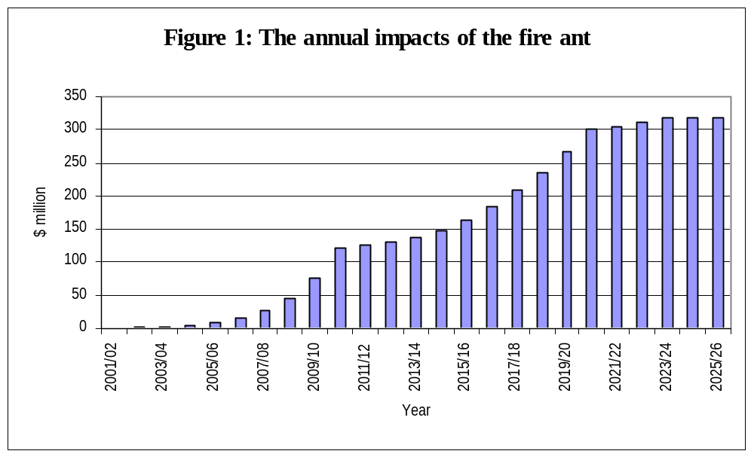
The present value of the total impacts over the period 2001/02 to 2023/24 is $665 million. As Figure 2 indicates, over three quarters of these costs are due to household impacts. Of these, over two thirds occur in the Auckland region. Infrastructure impacts and government expenditure are similarly concentrated in the Auckland region and agricultural impacts in the rest of the North Island.

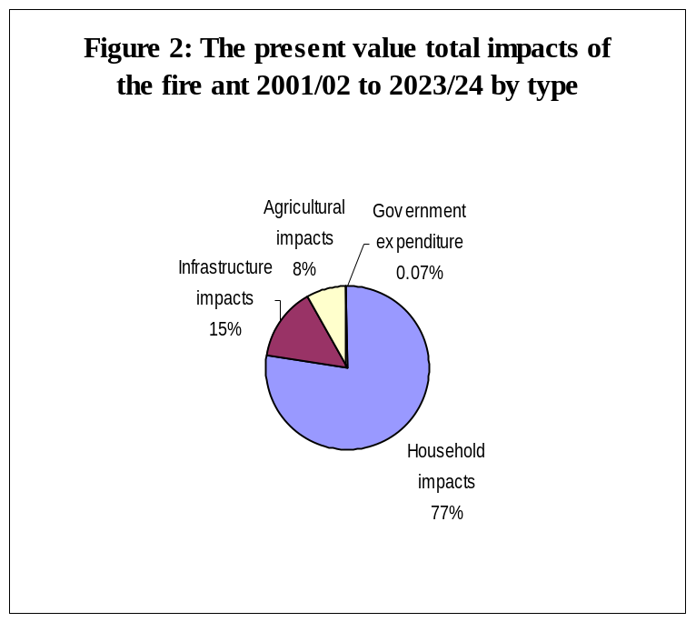
It is therefore not surprising that, as illustrated in Figure 3, two thirds of the present value total impacts over this period occur in the Auckland region (of which all but two per cent are household and infrastructure impacts). The concentration of all but agricultural impacts in the Auckland region is attributable to not only the warmer climate more favourable to the fire ant, but also this being where the fire ant first establishes in New Zealand (impacts in this region therefore occurring sooner and, accordingly, having relatively higher values in present value terms). Impacts in the upper South Island are low in comparison given the lower population, less favourable climate and distance from the initial establishment of the fire ant.

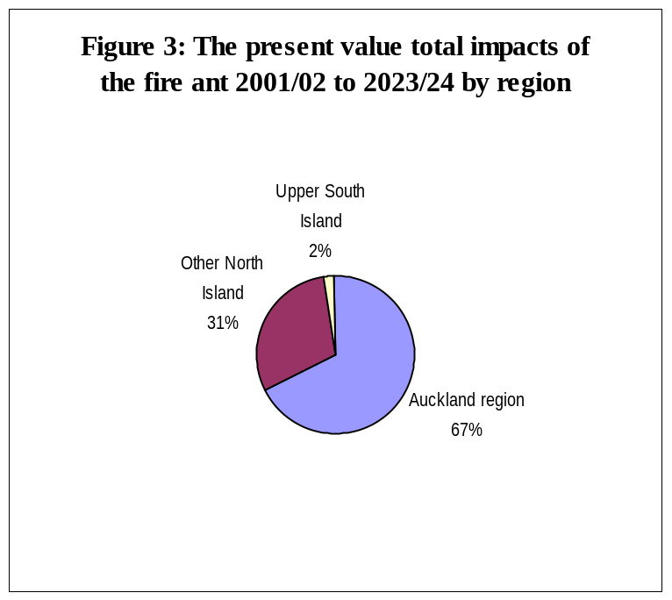
With future growth in key variables, such as population, the impacts could be greater. Conversely, over time, research into fire ant control may improve the effectiveness and/or reduce the cost of fire ant treatment.

The key uncertainty in this economic impact assessment is the extent to which the fire ant would proliferate in New Zealand in terms of its range, density, activity and rate of spread.

Additional to the impacts modelled are costs and possibly some benefits associated with a number of impacts not evaluated. A potentially major area of impacts is that of the environmental impacts of the fire ant, and of fire ant treatment, including effects on native species. Given uncertainty as to the impacts of the fire ant on New Zealand’s indigenous flora and fauna and, both directly and indirectly, on recreation and tourism activities, together with difficulties in determining the value to society of the environmental assets affected, the environmental impacts of the fire ant are not represented in this economic impact assessment but could be considerable.

Conclusion

This evaluation of selected impacts on households, infrastructure and agriculture suggests that, following range expansion and consolidation, the full annual costs of living with the fire ant, under minimal government intervention, in the North Island and upper South Island of New Zealand would be at least $318 million. The present value of the total impacts over a 23-year period of range expansion and consolidation from initial establishment is indicated to be at least $665 million. This is dominated by impacts on households and impacts in the Auckland region. Not included in these estimates are a number of impacts not evaluated, most notably the environmental impacts of the fire ant, including risks to indigenous flora and fauna, which could be considerable.

References

Adams, C.T. and Lofgren, C.S. (1982) Incidence of stings or bites of the red imported fire ant and other arthropods among patients at Ft. Stewart, Georgia, USA, Journal of Medical Entomology, 19, pp. 366-370.

Barr, C.L. and Drees, B.M. (1996) Texas cattle producers survey: impact of red imported fire ants on the Texas cattle industry, final report, November 1996.

Callcott, A.A. and Collins, H.L. (1996) Invasion and range expansion of imported fire ants (Hymenoptera: Formicidae) in North America from 1918 to 1995, Florida Entomologist, 79(2), pp.240-251.

CSIRO Entomology (2001) The suitability of the climate of New Zealand for establishment of the red imported fire ant Solenopsis invicta, draft report prepared for the National Centre for Disease Investigation, Ministry of Agriculture and Forestry, New Zealand, by Sutherst, R.W., CSIRO Entomology, Commonwealth Scientific and Industrial Research Organisation, Brisbane, Australia, August 2001.

Diffie, S.K. and Sheppard, D.C. (1991) Imported fire ant management: results of applied research - result demonstrations 1987-1990, University of Georgia, in Sparks et al. (1999).

Drees, B.M., Reinert, J.A. and Vinson, S.B. (2000) Red imported fire ants may find some landscape design elements unattractive, Fire Ant Plan Factsheet 26, Texas Agricultural Extension Service, Texas A&M University, March, 2000.

Kompas, T. and Che, N. (2001) An economic assessment of the potential costs of red imported fire ants in Australia, Australian Bureau of Agricultural and Resource Economics, preliminary report, June 2001.

Lard, C.F., Hall, C. and Salin, V. (2001a) The economic impact of the red imported fire ant on the homescape, landscape and the urbanscape of selected metroplexes of Texas, Faculty Paper 01-3, Department of Agricultural Economics, Texas A&M University, February 2001.

Lard, C.F., Willis, D.B., Salin, V. and Robinson, S. (2001b) Economic assessments of red imported fire ant on Texas’ urban and agricultural sectors, Department of Agricultural Economics, Texas A&M University and Department of Applied and Agricultural Economics, Texas Tech University.

Lennon, L. (1998) Fire ant management options for golf courses, Fire Ant Plan Fact Sheet 17, Texas Agricultural Extension Service, Texas A&M University, October 1998.

Lofgren, C.S. (1986) The economic importance and control of imported fire ants in the United States, in Vinson, S.B. (ed.), Economic impact and control of social insects, Praeger: New York.

Lofgren, C.S. and Adams, C.T. (1982) Economic aspects of the imported fire ant in the United States, in Breed, M.D., Michener, C.D. and Evans, H.E. (eds.), The Biology of Social Insects, Westview Press: Boulder, Colorado.

Loope, L. (2000) Solenopsis invicta, in report to the Co-ordinating Group on Alien Pest Species, http://hbs.bishopmuseum.org/ants/Solenopsis/Solinv.html

Merchant, M. (1998) Fire ants and the Texas IPM in schools program, Fire Ant Plan Fact Sheet 20, Texas Agricultural Extension Service, Texas A&M University, December 1998.

Miller, S.E., Henry, M.S., Vander May, B.J. and Horton, P.M. (2000) Averting-cost measures of the benefits to South Carolina households of red imported fire ant control, Journal of Agricultural and Urban Entomology, 17(3), pp. 113-123.

MAF (1999) Ministry of Agriculture and Forestry, New Zealand, www.maf.govt.nz/statistics

MAF (2000) Ministry of Agriculture and Forestry, New Zealand www.maf.govt.nz/statistics

Morrison Silva, J. (1991) The ant from hell, www.pctonline.com May 1991.

PA Consulting Group (2001) Future proofing New Zealand’s clean green image, report prepared for the Ministry for the Environment, New Zealand by Thornton, S. and Paul, S., PA Consulting Group, Wellington, New Zealand, July 2001.

Scott, W.G., Scott, H.M., Lake, R.J. and Baker, M.G. (2000) Economic cost to New Zealand of foodborne infectious disease, The New Zealand Medical Journal, 113(1113), pp. 281-4.

Segarra, E., Teal, S., Moates, K., Polk, W. and Coates, C. (1999) Economic impacts of the red imported fire ant in Texas: the search for economically feasible solutions, final report 1997-1999, Department of Agricultural and Applied Economics, Texas Tech University.

Sparks, B.L., Hudson, W., Ruberson, J. and Ross, K.G. (1999) Section VII. Fire Ants, in Georgia Integrated Pest Management, Summary of losses from insect damage and costs of control in Georgia 1997, Department of Entomology, University of Georgia

Statistics New Zealand (1999) New Zealand Official Yearbook 1999, Wellington, New Zealand.

Statistics New Zealand (2001b) Tourism satellite account 1997, May 2001, Wellington, New Zealand.

Teal, E., Segarra, E., Moates, K., Barr, C. and Drees, B. (1998) Spatial economic impacts of the red imported fire ant on the Texas cattle industry, Technical Research Report T-1-484, College of Agricultural Sciences and Natural Resources, Texas Tech University, September 1998.

Texas A&M University (1998) Fire ant trails: news from the Texas imported fire ant research and management plan, 1(2), www.fireant.tamu.edu February 1998

Texas A&M University (2001) Texas imported fire ant research and management plan, www.fireant.tamu.edu

Transit New Zealand (2000) Annual report 1999/2000.

Treeby, B. (1997) Urban tree estate amenity values and pest risk, report prepared for Forestry Biosecurity Standards Team, Ministry of Forestry, New Zealand, December 1997.

University of Arkansas (2001) Environmental and economic impacts of the red imported fire ant, Division of Agriculture, www.arnatural.org/fireants/impact.asp

University of Queensland (2001) Red imported fire ants, www.uq.edu.au/entomology/fireant.html

USDA (1997) 1997 Census of agriculture, National Agricultural Statistics Service, United States Department of Agriculture.

VanGelder, E. (2001) The ant that could conquer Hawai’i, Hawai’i Horticulture, 4(2), pp. 9-10.

Vinson, S.B. (1997) Invasion of the red imported fire ant (Hymenoptera: Formicidae): spread, biology and impact, American Entomologist, 43, pp. 23-39.

Western Region Integrated Pest Management Network (2001) Fireants, Colorado State University, www.colostate.edu/depts/IPM/natparks/fireants.html

